**Project 02_10_01**

In this Project we will modify the Online Stores Web site to add more shopping cart functionality.

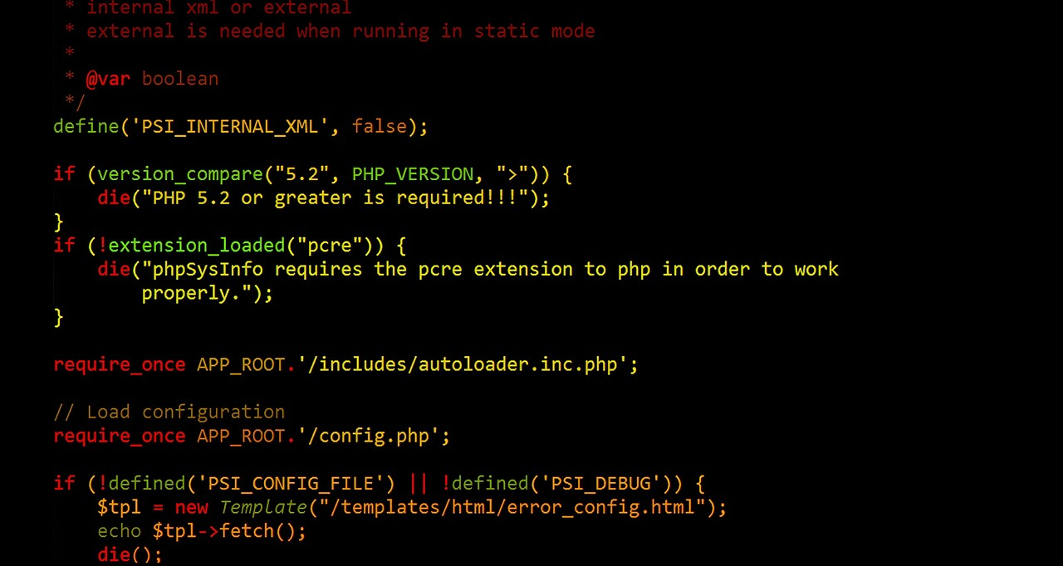   
Modify the Online Store class by adding two new methods, ***removeItem()*** and ***emptyCart()***. These methods allow you to remove individual items or all items from the shopping cart.

Add a ***checkout()*** function to the class. It will support customer check out by saving order information to a new database table that you will design and construct.

Implement another module named ***Checkout.php***. It will display the Store Name and the ***orderID***. It will display a table showing the contents of the shopping cart. It will allow a checkout submission.